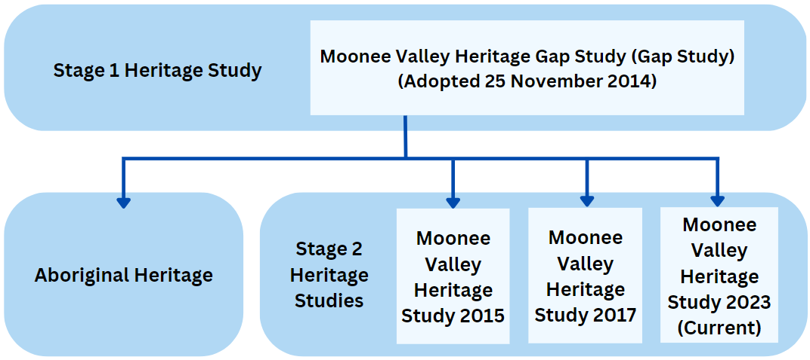



Heritage places are important to our community.
Protection ensures they survive for future generations to view, understand and appreciate. The Planning and Environment Act 1987 requires Council to protect places of local heritage significance within Moonee Valley.
Council protects our heritage for future generations.
Buildings, streetscapes and parks can provide a valuable link to both our sense of place and to previous generations. These physical places tell us something about the past and about the communities and people who lived and worked in Moonee Valley. By preserving Moonee Valley’s heritage, we preserve a tangible part of the past for future generations.
The Moonee Valley Heritage Study 2023 is part of a program of work to protect places of heritage significance in Moonee Valley.
The Moonee Valley Gap Study 2014 was a preliminary assessment of properties, precincts, and places in Moonee Valley. The Gap Study groups places and areas together by theme and priority and identifies gaps in our existing heritage protection. These were classified as high, medium or low priority.
These have then been investigated in detail as part of successive heritage studies:
- The Moonee Valley Heritage Study 2015 assessed commercial places, transport-related places, industrial and suburban infrastructure, and community-use buildings.
- The Moonee Valley Heritage Study 2017 assessed residential Victorian, Edwardian and interwar places, precincts, and extensions to existing precincts.
- The Moonee Valley Heritage Study 2023 currently under consultation covers different eras of our history from Victorian to post-war.
The Gap Study also identified several Aboriginal Heritage places as having potential heritage significance. Protection of Aboriginal cultural heritage places and objects is guided by the Aboriginal Heritage Act 2006, with the Victorian Aboriginal Heritage Council the responsible authority.

About the heritage study
Heritage places are part of the rich tapestry of who we are as a community.

9243 8888 | mvcc.vic.gov.au


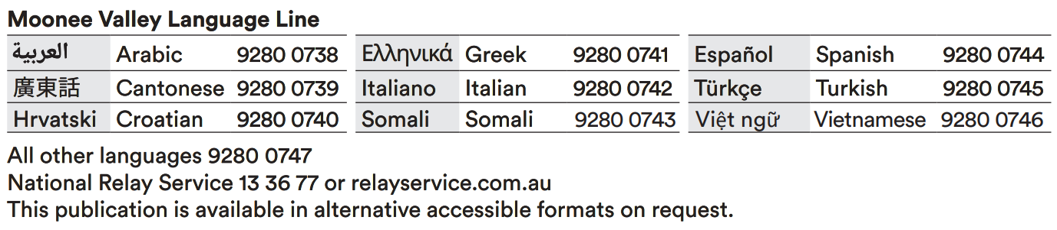
The Statement of Significance establishes the importance of a place and addresses heritage criteria.
It is a key part of the citation prepared in accordance with the Victorian Government’s Planning Practice Note 1: Applying the Heritage Overlay. This practice note provides guidance on the use of the Heritage Overlay and the eight criteria (Criterion A through H) that are used to assess the value of a heritage place. The criteria relevant to each property are outlined in the ‘Why is it Significant?’ section of the Statement of Significance.
The study will be implemented through an amendment to the Moonee Valley Planning Scheme.
The Planning and Environment Act 1987 sets out the process that must be followed. Council must first request authorisation from the Minister for Planning to prepare the amendment.
If authorised, a formal community consultation will take place, with residents given a further opportunity to provide feedback on the proposed amendment. Council will again consider all submissions received during the consultation period and may vary the findings in the study to address any matters raised.
If matters cannot be resolved, the submissions will be referred to an independent planning panel appointed by the Minister for Planning. The panel will consider all submissions referred and make recommendations about the amendment.
The panel report and amendment will then be considered at a Council meeting and if adopted the amendment is referred to the Minister for Planning for their approval.
Scan the QR code or visit yoursay.mvcc.vic.gov.au/heritage
for further information.
We are currently undertaking informal consultation on the draft Moonee Valley Heritage Study 2023.
This is the first opportunity for you to have your say on the study. Submissions made will be considered by Council officers when finalising the study.
Once finalised, the study will be presented at a Council meeting. A Council decision is then required to proceed with a planning scheme amendment.
The heritage study is a detailed investigation into properties and places which may have heritage significance.
We follow state government processes when preparing heritage studies. Heritage experts have researched each place and presented their findings including:
- research into the history of a place or area
- information as to why a place may be significant, and what features are significant
- recommendations to protect the place though a Heritage Overlay
- a Statement of Significance for each place or precinct.

