

Draft Disability Action Plan 2024-2025

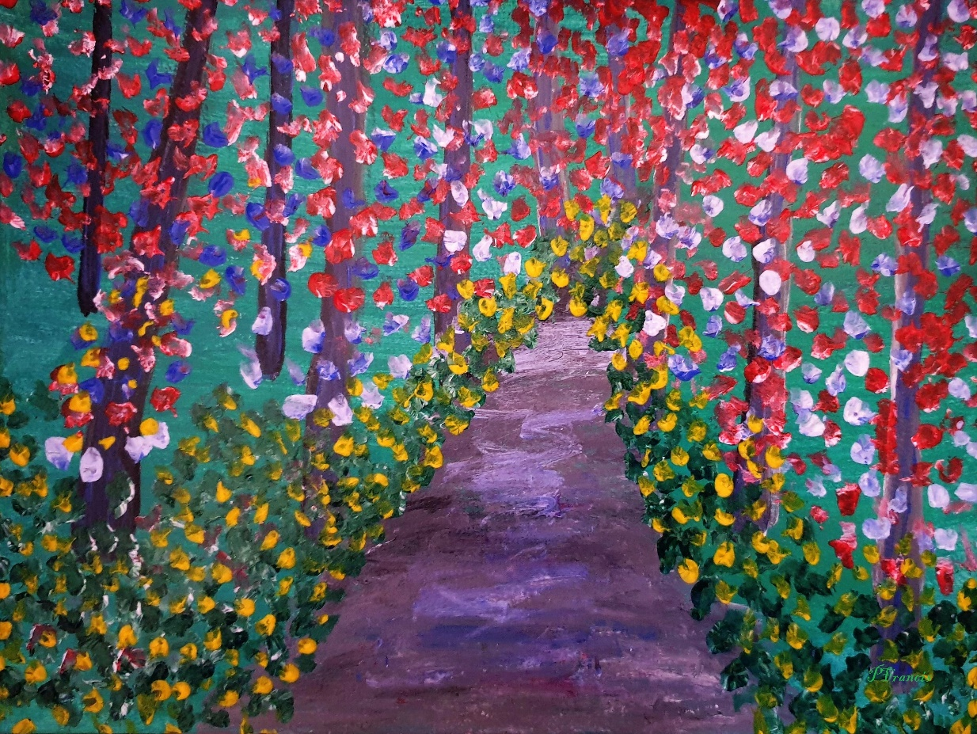

Contents
Acknowledgements 3
Message from the Mayor 5
Message from the CEO 6
Message from the Disability Advisory Committee (DAC) 7
Introduction 8
Language 8
Ableism and intersectionality 9
Human Rights Model 9
Key statistics and demographics 11
People with disability in Moonee Valley 11
Carers in Moonee Valley 12
Our Disability Action Plans 13
What is a Disability Action Plan? 13
Council’s commitment 13
Legislative and policy context 14
Our journey so far 14
Community consultation 16
Actions - Disability Action Plan 2024-2025 18
1. Inclusive communities 19
2. Health, housing and wellbeing 21
3. Fairness and safety 22
4. Opportunity and pride 23
Find out how we are progressing 25
Summary 26
Glossary 27
References and relevant documents 31

Accessibility
Accessibility is important to us, so we make sure that we use large print and high contrast for printed and digital flyers. We also provide plain text versions on our website so people who use screen readers can access information. We aim to provide translated versions where possible. Please contact us if you would like information provided in an accessible format. Contact Council on tel. 9243 8888 or email. Council@mvcc.vic.gov.au

Acknowledgements

Front cover artist

Image credit: Patrick Francis
Title: Into the woods
Date: circa 2022, Material: Acrylic on paper, Size: 30cm (W) x 21cm (H) x 0.1cm (D)

Description of Artist inspiration:

‘On a visit to the Royal Botanic Gardens in Melbourne, Patrick was entranced by the kaleidoscope of colours and textures of the plants from around the world, and putting brush to paper, highlighted a segment in his own inimitable style.’
See more at: Patrick-Francis.weebly.com | Facebook.com/PatrickFrancisArtist

Acknowledgement of Country
Moonee Valley City Council respectfully acknowledges Wurundjeri Woi-wurrung as the Traditional Owners of the land, waterways, valley and hills of Moonee Valley.
Our Reconciliation journey is built on the power of listening to stories of the Elders, supporting the continuation of culture through ceremony, language and truth telling.
Our commitment to Wurundjeri Woi-wurrung is based on friendship and admiration for their resilience and courage through times of hardship, disconnect and dispossession.
We respect connection to Country which goes back tens of thousands of years and is a relationship like no other, Council honours this spiritual link which continues into the future.

Moonee Valley City Council gagook ngarrgooyn Wurundjeri Woi-wurrung ngarrgoo noogal biik-al, yanoonoong-al, doon-ngorrm-al ba ngoorrak-al Moonee Valley-al
ngarrng-adha yanayi wirratj ngiya balit-oo ngarrng-al marrening-dhana nanggit-al, yadagoonar yoorroonga goorrkwoodjil tanderrum-a, Woorroong ba goonga-dhoomba
ngal-al Wurundjeri Woi-wurrung ngiya girrip-djerring-a boorndap yooma-dhan ba ngaboo yalingboo brenggarr-al dhagoong berrbang-al ba goongnoorradhoo-wal.
yooma-nganyin gagook berrbang biik-ooth yana ngarrak woordiyalyal woodhanoo birring ngawayn ba girrip-inganyin dandawoorring dhagoong yoowang, Council dooliyn marragayil moorroop yoorronga yirramboi.
Translation for this Acknowledgement was provided by Wurundjeri Woi-wurrung Elder Aunty Gail Smith, language keeper.

Figure 1 Image of flags and symbols acknowledging Council's support for Aboriginal and Torres Strait Islander, and Lesbian, Gay, Bisexual, Transsexual, Intersex, Queer, Asexual + communities

LGBTIQA+
We pay our respects to those amongst the lesbian, gay, bisexual, trans, and intersex communities who have worked to support the improved health and wellbeing of their peers, children, families, friends, and country. We honour the elders in the diverse communities of which we are a part and we celebrate the extraordinary diversity of people’s bodies, genders, sexualities, and relationships that they represent.

Disability
We respectfully acknowledge people with disability, Neurodiverse people and Carers as we strive for a more accessible and inclusive society. We thank those who have advocated for disability equity before us and those that continue this work now.
In particular, we recognise and value the contribution of the current and former members of Council’s Disability Advisory Committee and the significant advocacy they provide while advising, identifying and guiding Council to empower people with disabilities.

Message from the Mayor
To be published in final version

Message from the CEO
To be published in final version

Message from the Disability Advisory Committee (DAC)
To be published in final version

Introduction
The Disability Action Plan 2024-2025 outlines key actions to be implemented over two years (between January 2024 and December 2025) by Moonee Valley City Council. The Plan seeks to improve access and inclusion to everyday life – while removing barriers such as providing information to the public on accessibility in Council buildings and the way that Council recruits staff, with the objective of empowering people with disability, Neurodiverse people, their families and Carers in our community to fully participate in civic life.

Language
‘We acknowledge that people with disability and Neurodiverse people have different preferences regarding how they describe their disability. We further recognise that there is no universal conceptualisation of disability, which is perceived in culturally specific ways.’
(Inclusive Victoria: State Disability Plan 2022-2026)
Like many other organisations, Council has historically utilised person-first language in all of our communications to Community. For example, ‘person with a disability’. We appreciate that language is a powerful tool for changing community attitudes and understand that listening to a person’s preferred way of being referred to is integral to building a relationship of trust with our community. For some parts of our community, identity-first language is preferred. For example, ’a d/Deaf person’ or ‘Neurodiverse person’. We acknowledge that not every person identifies with the term “disabled” and might prefer to say, ‘Additional Needs’, or ’All Abilities’. Some people do not see themselves as ‘disabled’, rather the environment we all live in causes their disabilities.
“Don’t like the word “disability”. I do not relate to this word, and nor do many others with non-visible disabilities. Don’t want to have to declare my disabilities to access information or services.”
Quote from DAC member responding to Community Engagement – Disability Action Plan (July 2023)
Ability - Disability is a large tent
There are various ways in which persons may experience disability, and this experience can be different over time. The World Health Organisation (WHO) states:
‘Disability is part of being human… A person’s [physical and social] environment has a huge effect on the experience and extent of disability. Inaccessible environments create barriers that often hinder the full and effective participation of persons with disabilities in society on an equal basis with others’.
As a community we often initially consider that a person with disabilities will be visible to others and obvious to see.
‘Some disabilities, conditions or chronic illnesses are not immediately obvious to others’.
(Hidden Disabilities Sunflower Scheme)
‘Autism is not a disease. Autistic people are not ill because of their Autism. Autism cannot be diagnosed with a blood test or cured with medicine. Rather, Autism is a neuro-developmental difference that can manifest itself in communication differences or differences in social skills and interaction. Because Autism is part of everything we experience and the way we are in the world, it is an important part of our identity. We cannot imagine an Autistic person without their Autism’.
(Reframing Autism)
“I would like to be able to walk proudly with my son along the shopping strips of Moonee Valley… [and not] … feel that we are not welcome because there is a lack of understanding of our needs by retail staff and the community....”
Quote from person responding to Community Engagement – Disability Action Plan (July 2023)
It is common for people to have the expectation that everyone does things in the same way. This can lead to assumptions about people’s ability to perform an activity or task. These assumptions can impact the way we write things, plan and design. We are learning more about how people have diverse ways of performing the same activities and that this may involve equipment or support from others. We have access to a growing body of knowledge on Universal Access, the principles of which can be engaged to continue to work towards an inclusive Moonee Valley.
Throughout this document the term ‘people with disability’ is used to describe the wider group of people with disabilities including psychosocial disability or mental illness, Neurodiverse people, Deaf people, and other people who may benefit from the actions within this Plan.

Ableism and intersectionality
Intersectionality describes how different parts of a person’s identity or circumstances – such as age, race, culture, disability, gender, location or religion – intersect and combine to shape people’s life experiences, including of discrimination. Ableism is discrimination or prejudice towards people with disability. Ableism interacts with other forms of discrimination, such as gender inequity, racism, homophobia, biphobia, transphobia, and ageism. This creates multiple and intersecting forms of systemic discrimination for Aboriginal people, women, LGBTQIA+ people, multicultural people, older people and young people. Like all forms of discrimination, ableism may be conscious or subconscious conduct.
Ability is only one part of any person or community. Intersectionality recognises that the different parts of someone’s identity and circumstances cannot be disentangled or considered in isolation. Intersectionality is a way of seeing the whole person. An understanding of intersectionality is key to designing and implementing effective policies, programs and services.

Human Rights Model
Council works toward a social model of disability – acknowledging that it is the environment around the person which creates the disability, and if we identify and remove these barriers people will be more able to access services and have a higher rate of participation in civic life.
However, this approach does not consider the very real impact of impairment which people with disability experience in their lives such as chronic pain and shorter life expectancy.
The Human Rights model acknowledges that removing mainstream barriers is only one part of the approach needed for inclusion. Measures may need to be put in place to improve outcomes for people with disability, to aim for equality with others in our community.
Council acknowledges that people with disability are the experts in their own situation and can be consulted with in the development of new policies, laws and programs that may affect them. Council will continue to collaborate with the Disability Advisory Committee to further our understanding of people with disability, Neurodiverse people and Carers.
Council will uphold, promote, and protect the rights of people with disability, Neurodiverse people, and Carers to live independently and participate fully in life across the Moonee Valley Community.
“We should be going to the same buildings, same cafes, same libraries without barriers.”
Quote from person responding to Community Engagement – Disability Action Plan (July 2023)

Key statistics and demographics
(infographics to be supplied in final version)
15% people with disability
6% have a need for assistance in their day-to-day lives
15% are Carers of people with disability, health conditions or due to older age

People with disability in Moonee Valley
Council obtains data from the few sources that are available regarding people with disability and unpaid Carers: namely the Australian Bureau of Statistics (ABS) Census and ABS Survey of Disability, Ageing and Carers (SDAC). The Census uses language describing ‘activity limitation’ and uses gender bound language, meaning the survey offers only male or female genders to select as an identity. It is only in recent years (2016 and 2021) that the Census has collected data on “Has need for assistance with core activities”.
The new National Disability Data Asset (NDDA) and the streamlining of internal systems to collect local data will potentially inform development and implementation of actions in this and future Disability Action Plans.
In 2018, there were over 18,000 people in the City of Moonee Valley living with a disability (approximately 14.5 per cent of the local population).
In 2021, there were 7,372 people living in the City of Moonee Valley that needed assistance with activities for daily living (approximately 6 per cent of the local population). The older age cohorts in our community have a higher number of people who need assistance with daily living.

Figure 2 Number of people with a need for assistance with daily living by age cohort

Carers in Moonee Valley
Information about Carers tells us that 15 per cent of people in the City of Moonee Valley aged 15 years and over provide unpaid assistance to a person with disability, long term illness or older age.
People aged between 45 and 64 years were most likely to be Carers. It is important to note that there are 793 Young Carers (aged 15- 25 years) in our community. Women are more likely to provide unpaid assistance to people living with disabilities (female 17%; male 13%).

Figure 3 Number of people who provide assistance to a person with disability, long term illness or older age by age cohort

Our Disability Action Plans

What is a Disability Action Plan?
Disability Action Plans (DAP) are a legislated requirement of all local government bodies (under the Victorian Disability Act 2006).
Yearly updates on the Plan’s progress are included in Council’s Annual Report.
“The purpose of a DAP is to encourage, recognise and promote an active commitment to eliminating disability discrimination and to promote the recognition of the rights of people with disability. [It] sets out your organisation’s strategy for identifying and addressing practices which might result in discrimination against people with disability and to promote the recognition of the rights of people with disability. It details how an organisation is making its workplace, products and services accessible and inclusive to people with disability and informs the public how it is approaching diversity and inclusion”. (Australian Human Rights Commission)
The Disability Discrimination Act (1992) stipulates that Council must provide a copy of their DAP for inclusion on the DAP Register held by the Australian Human Rights Commission.

Council’s commitment
Council is responsible for providing a range of community services for residents and businesses within Moonee Valley, such as:
- childcare and kindergartens
- aged, youth and disability services
- libraries
- animal registration
- street cleaning
- parking management
- waste collection and recycling
The services, events and activities vary amongst Local Government municipalities; however, all Councils in Victoria are governed by the same Local Government Act (2020).
Councils also manage public infrastructure such as community buildings, local footpaths and roads, parks and gardens, bridges, drains and street furniture, environmental areas, recreation centres and sporting grounds.
In the City of Moonee Valley, alongside the local community, we have developed Moonee Valley 2040 (MV2040): Our long-term vision that guides how we will make Moonee Valley a great place to live for current and future generations.
The Council Plan and Health Plan (2021-2025) outlines the strategic directions and focus for how we will service our community for each four-year term of our Councillors. Under the theme ‘Fair’ (Qeente Boordup) Council has committed to:
‘F4. Support people living with a disability, the elderly, and carers to have healthy, active, and independent lives, by delivering the Disability Action Plan.’
The MV2040 Action Plan - Fair (Qeente Boordup) includes two actions relevant to the Plan:
‘Action 1.3.2: Embed Council’s access, inclusion and equity principles across service delivery and neighbourhoods’
‘Action: 4.1.4: Partner with target populations, other levels of government, the service sector and community stakeholders to advocate for and address their varying needs, aspirations, and issues’
As an employer of over 1,000 people, Council is also well positioned to model to the community its relationship with staff who have disabilities, are Neurodiverse and whom are Carers, and work towards a staffing group that is reflective of the community we serve.

Legislative and policy context
In the development of this Disability Action Plan, we are guided and informed by current international, Federal, and State legislation and policy and Council’s other strategic plans and policies.
This policy context can change from time to time, so we need to keep up to date on these changes and adjust our activities for inclusion of people with disability, Neurodiverse people and Carers accordingly.
International  United Nations Convention on the Rights of Persons with Disabilities  National  Disability Discrimination Act (1992)  Australia’s Disability Strategy 2021-2031  State  Charter of Human Rights and Responsibilities Act (2006)  Disability Act (2006)  Equal Opportunity Act (2010)  Local Government Act (2020)  Gender Equality Act (2020)  Carers Recognition Act (2012)  Inclusive Victoria: State Disability Plan 2022-2026 | Moonee Valley City Council  Moonee Valley 2040 (MV2040)  Council Plan and Health Plan (2021-2025)  MV2040 Action Plan - Fair (Qeente Boordup)  Accessible Parking Review & Strategy (2015)  Bagarru Bagarru Djerring Reconciliation Plan (2022-2025)  Community Engagement Policy (2021)  Gender Equality Action Plan (2021-2025)  Gender Impact Assessment - Disability Action Plan (2024-2025)

Our journey so far
Moonee Valley’s Disability Action Plan 2014-2023 was developed to continue Council’s previous work (achievements of the Diversity, Access and Social Inclusion Strategy 2008 and the Diversity, Access and Equity Policy 2014) and provided a whole of Council approach to strive for broader inclusivity within the City of Moonee Valley.
The Disability Action Plan 2014-2023 was for a period of 10 years and contained 51 actions.
In the life of the 2014-2023 Plan, there have been many changes in our society’s understanding and attitudes towards disability, including the introduction of the National Disability Insurance Scheme (NDIS) and the impacts of the COVID-19 pandemic. Additionally, with changes in legislation over that 10-year period, Council now has a Community Engagement Policy and a clear role with Emergency Management in our community.
These newer obligations are identified in this Plan as specific actions to address with a disability access lens.
This Plan is for two (2) years, the two-year time frame allows for our next plan, to align with the future Council Plan and Health and Wellbeing Plan.
Disability Action Plan 2014-2023 concluded in December 2023, with the following outcomes for the 51 actions;
 | 39 actions completed with no further action being required
 | 5 actions partially complete
 | 1 action not started
N/A | 6 actions were no longer relevant due to changes in the external environment over the course of the plan (including inception of NDIS & the effects of the COVID-19 pandemic)
The five partially completed actions have been carried over to be finalised in the Disability Action Plan 2024-2025.
When delivering the DAP 2014-2023 actions, we partnered with other levels of Government and Government agencies, service providers, local organisations, and advisory committees – in particular, Council’s Disability Advisory Committee. We will continue to collaborate with others in this same way into the future, to improve access and inclusion.
Key achievements from Disability Action Plan 2014-2023 include:
- Annual event to celebrate and foster improved attitudes towards people with disability in Moonee Valley, often coinciding with International Day for People with Disability (3 December).
- The Disability Advisory Committee (formally Disability Reference Group) are a group of people with living experience of disability that meet regularly to advise Council on access and inclusion issues.
- ‘Include Everyone Guide’ (2017) was developed to support inclusive practice across the organisation’s events and activities.
- A Fees and Services Policy (2021) in Aged and Disability Services provides low/no cost services including meals, transport and home care for those eligible for Home and Community Care Programs for Young People (HACC PYP) and Commonwealth Home Support Program (CHSP).
- The Companion Card (federal) and Carer Card (state) programs are utilised at Leisure Centres and The Clocktower.
- In 2015 Council engaged key community stakeholders and reviewed parking spaces in the activity centres across the municipality for compliance with the Australian Standards (AS). The Accessible Parking Review and Strategy (2015) includes a plan to retrofit spaces that were not AS compliant. These recommendations continue to be implemented.
- In 2016 Council opened Crown Street Stables Café, which provided valuable work experience to people with disability exploring a career in hospitality. In total 19 trainees spent up to 16 weeks in paid, on the job training with café staff. Crown Street Stables Community Café won an LGPro Aged and Disability Services Award (2017) for an outstanding project.
- Council’s Procurement Policy and Social Procurement Guidelines (2019) require staff to apply an evaluation score preference of 5 per cent for any social enterprise, Indigenous business or Australian Disability Enterprise (ADE).

Development of DAP 2024-2025
Inclusive Victoria: State Disability Plan 2022-2026 engaged with the Victorian community to develop actions across 4 pillars. The Moonee Valley City Council Disability Action Plan has been aligned with these 4 pillars from Inclusive Victoria, to ensure a themed localised implementation of the State Plan. The 4 pillars have been interpreted to 4 themes at local level by aligning the following responsibilities under each theme.
Community consultation findings were themed in alignment with the four pillars of the Inclusive Victoria: State Disability Plan 2022-2026. The following interpretation of the State’s pillars to a local government context were used to guide the theming of findings:
- Inclusive communities
  - accessible transport and infrastructure
  - participation in community activities that support social connection and physical & mental health
  - information available in accessible formats
- Health, housing and wellbeing
  - access to affordable housing and health care
  - access to services and supports that meet the diversity of individual needs
  - supports for Carers
- Fairness and safety
  - people with disability need to feel safe and respected
  - freedom from disability-related discrimination and bullying
  - freedom from violence, abuse and neglect
- Opportunity and pride
  - people with disability should have opportunities to pursue and achieve their aspirations and contribute to the community
  - access to education and the opportunity to participate in meaningful, paid employment
  - active engagement in civic participation means the voices of people with a disability and Carers are heard
  - the contributions of people with disability and Neurodiverse people are recognised, valued and celebrated.

Community consultation
During May 2023 we sought feedback on Council’s approach to developing this Plan and the current and emerging themes for people with disability and Carers. We consulted Wurundjeri Elders, the Disability Advisory Committee and industry stakeholders who work with people with disability and Carers in Moonee Valley. This feedback guided Council in the initial stages of developing this Plan.
Key themes from these conversations included a need for improvements to:
- community awareness about diversity: promote contribution and diversity of people with disability (community attitudes, understanding and public perceptions/stigma)
- access to justice and whole of life health services for people with disabilities, Neurodiverse people and Carers
- availability of inclusive housing options: affordable housing; social housing choices
- accessible transport: advocacy for tram ‘super stops’ and other accessible transport or traffic safety issues
- employment, volunteer and training opportunities including work experience
- increase the opportunities to involve, engage and expand the contribution of the DAC as living experts on disability, Neurodiversity and Carers within Moonee Valley
- community modelling within Council’s own workforce e.g., employing people with disability, improvements to access and inclusion for staff

During July 2023 we engaged the community via Your Say, Council’s online community engagement tool. We asked two key questions:
- What does a good life look like for people with disabilities and their Carers in Moonee Valley?
- What would make Moonee Valley a better place for people with disabilities and their Carers?
We provided opportunities for feedback both online – where users could select their preferred language, and in hard copy. We added a new feature to our online survey which allows for a voice recording as a response (SpeakPipe).
In total, 94 responses were received from a diverse range of people in our community:
Present as infographic in final version
- 74 online surveys, 4 written submissions (e-mail), 1 SpeakPipe recording, 15 ideas posted to the YourSay page ideas board.
- 84% of responses were residents of Moonee Valley
- 61% were female, 34% male, 3% trans, non-binary or gender diverse, and 2% indicated they preferred not to say.
- Respondents were also asked if they identified as having a disability. More than half of respondents (55%) indicated yes, 44% no, and 1% stated they preferred not to say.
- Just under 73% indicated they identified as a Disability Ally (someone who supports and amplifies the cause of people with disabilities).
- 17% usually speak a language other than English at home (Vietnamese, Spanish, Greek, Italian, Maltese, Somali, Tamil and Turkish).
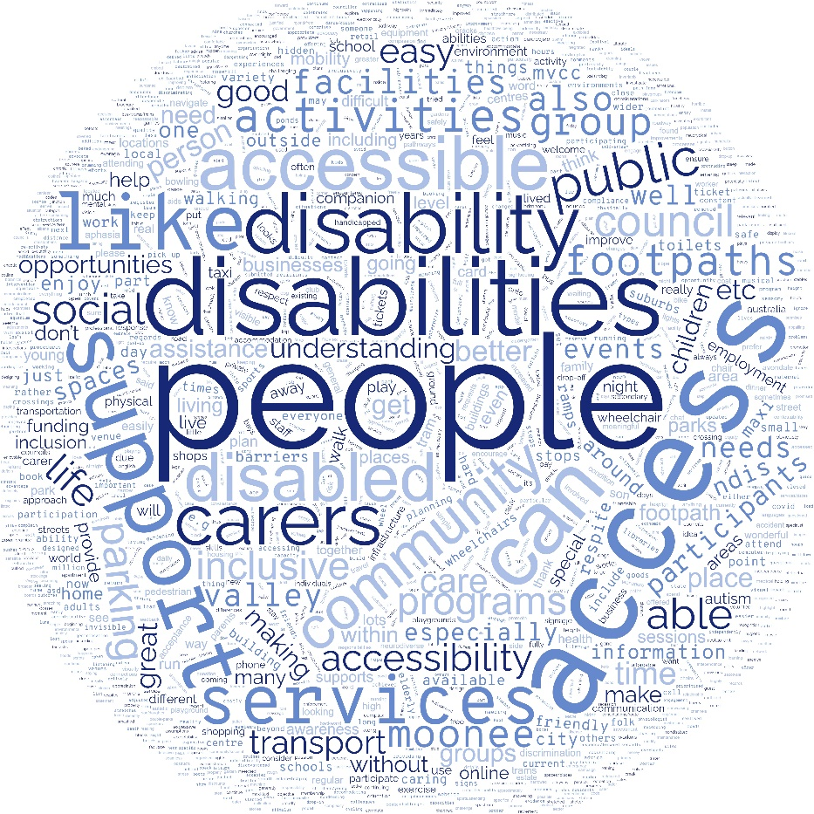
Figure 4 Word cloud of responses received during Community Engagement Report DAP (July 2023) - most frequent words are the largest in size. Created using www.wordclouds.com/

Actions - Disability Action Plan 2024-2025
The following provides a list of actions to be led by Moonee Valley City Council between January 2024 and December 2025.
These actions have been identified based on:
- action items carried over and learnings from the implementation of the previous plan Disability Action Plan 2014-2023
- current and emerging legislative and policy obligations
- input from the Disability Advisory Committee
- findings from consultation with community members and industry stakeholders
- Gender Impact Assessment
- advice from a range of Council staff (as action owners)

Inclusive communities

What we heard you say
In Moonee Valley, people with disability need accessible transport and infrastructure; the opportunity to equally participate in community activities that support social connection and physical & mental health and information available in accessible formats.
“Accessibility to parking close to shops, parks & other community infrastructure to facilitate access & participation.”
“When buildings are designed, they should be designed with access from the very beginning, rather than trying to alter an inaccessible building later.”
“Improved sports facilities that provide an inclusive environment for people with a disability. Avondale Heights Reserve in particular hosts all abilities and disability sporting groups (with) accessible bathrooms, ramp access from the car park, visually accessible signage, lighting, etc”
“Community education campaign about how to support and include people with disabilities in all parts of community life.”
Quotes from people responding to Community Engagement – Disability Action Plan (July 2023)

What we are doing
Action | Year of delivery | Responsible Department
1.1 Progress the upgrade of Accessible Parking spaces across the municipality as identified in the Accessible Parking Review and Strategy (2015). | 2024 and 2025 | Engineering Services
1.2 Update the MVCC Branding Guidelines to include and demonstrate Council’s commitment to accessibility, with advice that ensures Councils various communication mediums (print, social media, online, etc.) reflect the diversity within our community. | 2024 | Corporate Affairs
1.3 Conduct MVCC website review, including an accessibility audit. | 2024 | Corporate Affairs
1.4 Continue to monitor pedestrian access in the vicinity of Glenbervie Station. | 2024 and 2025 | City Works and Waste Management
1.5 Continue to review Council facilities in relation to their compliance with current Australian Standards Access to Premises (AS1428) under the Disability Discrimination Act (1992) (DDA) and principals of Universal Access (“Accessibility Audit”). Ensure this information and recommendations are considered for master planning, capital works delivery, building renewal program, advocacy for collaboration with other providers, potential advocacy for funding sources. | 2024 and 2025 | Property and Assets
1.6 Inclusion of a Changing Places Facility in the Ascot Vale Library upgrade. | 2024 and 2025 | Arts, Culture and Place
1.7 Review the new Djerring Flemington Hub programs for accessibility and inclusion. | 2024 and 2025 | Arts, Culture and Place
1.8 Commence a capital renewal program for Tactile Ground Surface Indicators (TGSI / tactiles) and dropped curb / pedestrian crossing upgrades. | 2024 | City Works and Waste Management
1.9 Educate traders and encourage adherence to footpath trading guidelines, where traders must provide clear footpath access of 1.2m (minimum). | 2024 and 2025 | Open Space and Amenity
1.10 Scope and build a business case for the installation of Automatic doors with sensor access to existing accessible change rooms at Ascot Vale Leisure Centre. | 2024 and 2025 | Sport and Recreation
1.11 Scope and build a business case for the installation of mobile pool hoists to provide an accessible entry to warm water pools / spa at Ascot Vale Leisure Centre and Keilor East Leisure Centre. | 2024 and 2025 | Sport and Recreation
1.12 Conduct a feasibility study into a new all access playground in the municipality. | 2024 | City Futures
1.13 Investigate the design and development of an interactive public facing Access Map. | 2025 | Corporate and Community Planning
1.14 Increase information available on Council’s website regarding accessibility for hireable Community Facilities, including provision of photos to demonstrate accessibility features. | 2025 | Sport and Recreation
1.15 Review the process for Council to receive feedback on accessibility concerns from community. | 2024 | Corporate Affairs

Health, housing and wellbeing

What we heard you say
In Moonee Valley, people with disability need access to affordable housing and health care, services and supports that meet the diversity of individual needs and provide support for Carers.

“People would be able to access support which is meaningful and relevant to their needs and their current situation”

“A Community Drop-In Centre - A place where people can visit to feel welcome and at home, to have a chat, and to ask for advice and assistance.”
“Opportunities for social engagement … within the municipality… Affordable housing opportunities within the area”
Quotes from people responding to Community Engagement – Disability Action Plan (July 2023)

What we are doing
Action | Year of delivery | Responsible Department
2.1 Ensure the Kindergarten Priority of Access criteria are applied through the Central Registration system so that children experiencing vulnerability, inclusive of children with additional needs, have priority access to Kindergarten. | 2024 and 2025 | Family and Children Services
2.2 Advocate for Housing within Moonee Valley that is affordable and inclusive for people with disability, mental illness and Neurodiverse people. | 2024 | City Futures
2.3 Continued advocacy across the sector to ensure home and community care services are locally available for people with disability and older people that need support to live independently in their home and community. | 2024 and 2025 | Young, Inclusive and Ageing Communities
2.4 Continued advocacy towards a diverse range of local programs, activities and events that provide information, support and recognition for unpaid Carers of people with disability, long term illness or older age. | 2024 and 2025 | Young, Inclusive and Ageing Communities

Fairness and safety

What we heard you say
In Moonee Valley, people with disability need to feel safe and respected, have freedom from disability-related discrimination and bullying and freedom from violence, abuse and neglect.
“Safe public transport, assistance if travelling at night”
Quote from person responding to Community Engagement – Disability Action Plan (July 2023)

What we are doing
Action | Year of delivery | Responsible Department
3.1 Develop and seek endorsement for a public Statement of Commitment to the prevention of family violence with an intersectional lens. | 2024 | Young, Inclusive and Ageing Communities
3.2 Person-Centred Emergency Preparedness training delivered to agencies, community service providers and MVCC employees who support people with a disability and other groups who may be at-risk in an emergency. | 2024 and 2025 | Emergency & Resilience
3.3 Promote greater sense of belonging and understanding through festivals and events such as Fest Able to celebrate International Day of People with Disability and 16 Days of Activism Against Gender Based Violence. | 2024 and 2025 | Young, Inclusive and Ageing Communities
3.4 Develop an outcomes measurement framework for the next disability action plan to improve the way we identify the difference made to people with disabilities and the community through inclusive, welcoming and accessible opportunities. | 2025 | Community and Corporate Planning

Opportunity and pride

What we heard you say
In Moonee Valley, people with disability should have opportunities to pursue and achieve their aspirations and contribute to the community. They have access to education and the opportunity to participate in meaningful, paid employment. Active engagement in civic participation means the voices of people with a disability and Carers are heard. The contributions of people with disability and Neurodiverse people are recognised, valued and celebrated.
“Listen directly to the feedback and ideas of people disabilities and carers. It's important to consult with them and actively involve them in decision making processes.”
“Can Moonee Valley do something to recognise businesses who go out of their way to welcome people with disabilities?”
“An accessible business award would be a great idea to highlight businesses that do a great job in making everyone feel welcome!”

Quotes from people responding to Community Engagement – Disability Action Plan (July 2023)

What we are doing
Action | Year of delivery | Responsible Department
4.1 During the scheduled review of the Community Engagement Policy (2021), work with the DAC to include a checklist on inclusive consultation to inform best practice. | 2024 | Corporate Affairs
4.2 Establish partnerships with local business, services, and sporting clubs with a view to create a greater number of work experience and volunteer opportunities including for people with disability. | 2024 | People and Culture
4.3 Establish internal partnerships with relevant Departments to create a greater number of work experience and volunteer opportunities, including for people with disability. | 2024 | People and Culture
4.4 Provide training for Council staff on disability that is specific to the delivery of their work plan i.e., Accessibility at events, Universal Access. | 2024 and 2025 | People and Culture
4.5 Commence Dementia training for library staff. | 2024 | Arts, Culture and Place
4.6 Build the capacity of Family and Children’s Services staff’s knowledge around inclusion, inclusion resources and referral pathways. | 2024 and 2025 | Family and Children Services
4.7 Establish an internal community of practice/working group for accessibility related topics, with an invitation to all Disability Action Plan action owners to participate. | 2024 | Young, Inclusive and Ageing Communities
4.8 Investigate how to enhance social procurement across Council, including with suppliers that support people with a disability. | 2024 | EPMO & Accountability
4.9 Include consideration of the needs of people with a disability through Gender Impact Assessments and identify mitigation actions to ensure that access and inclusion is optimised for people with a disability through new and revised programs, policies and services provided by Council. | 2024 | Community and Corporate Planning

Gender Equality Action Plan 2021 – 2025

Moonee Valley City Council’s Gender Equality Action Plan (GEAP) is its long-term commitment and actions to address workplace inequality and promote diversity and inclusion.

The following actions from the GEAP are highlighted in the Disability Action Plan, to provide a clear connection between the two action plans, and to demonstrate the actions towards diversity, access and inclusion already taking place. For further information please find the GEAP at MVCC Gender Equality Action Plan.
1.3.2 Create and maintain various Employee Resource groups (for groups such as LGBTQIA+, those with caring responsibilities, First Nations Staff, etc.
5.1.1 Introduce initiatives to address unconscious bias during recruitment stages and rollout to the People and Culture team, the Executive and management level staff and all hiring managers.
5.1.4 Create new ways to accept job applications to promote accessibility (e.g., video applications) and review current accessibility of the recruitment process.
6.1.3 Provide training to increase understanding of the important role of unpaid carers and promote support options available to unpaid.
7.1.2 Create and implement a calendar of events to celebrate diversity and promote understanding and inclusion. Hold internal events and calls to action that coincide with different religions, disabilities, ethnicities and LGBTQIA+ and family violence issues.
7.2.2 Launch traineeships/paid placements to encourage diverse staff (including First Nations, people with disability and other MV2040 target populations) to join workforce.

Find out how we are progressing

“Ensure actions are meaningful, achievable and resourced to be delivered as promised. It is not ok to keep carrying over actions that have not been achieved”
Quote from Industry Stakeholder during Community Engagement Disability Action Plan
We know that having a way to measure the meaningful impact of these actions is important to embed from the beginning of the Plan.
We continue to streamline internal reporting systems and data gathering mechanisms to support our reporting to the community.
For the life of this Plan, we will provide updates on how we are implementing the Actions from the Plan in a variety of ways as detailed in the table below:
Formal:  - Included in the Council Annual Report (Statutory Obligations section, published September each year).  - Excerpt from the Annual Report content will also be published separately (with visual and text content) and will be easy to locate on Council’s website.  - An information session (verbal presentation) will be offered for community to attend and hear about the Annual Report content. | Informal:  - Quarterly progress highlights to Disability Advisory Committee on the actions in the Plan  - Feedback to Wurundjeri Elders regularly through Consultation.  - Stories and updates throughout the year in Council publications/social media channels to recognise achievements.

Summary

Council has created the DAP 2024-2025 in collaboration with our partners, with actions for delivery across the whole of Council throughout a two-year period.
We have adopted the themes from Inclusive Victoria: State Disability Plan 2022-2026 to ensure that Moonee Valley Council are working to the broad aspirations of the wider community.
Aligning to the themes of Inclusive Victoria: State Disability Plan 2022-2026, enhances our ability to monitor progress and achievements - to ensure we are progressing with purpose towards intersectional inclusion, access, and fair outcomes for community.
Our actions and advocacy for Moonee Valley residents will have wider impact beyond the boundaries of the municipality.

Glossary
Term/Abbreviation | What it means in this Plan
ableism | Describes discrimination based on a person’s disability.
Access/Accessible/Accessibility | The extent to which people with disability can access places and information. Accessible documents may be available in multiple formats.
Accessible Parking | Parking bays that are larger than standard parking bays, following the dimensions outlined in the Australian Standards.  Users for accessible parking bays must display an Accessible Parking Permit to demonstrate their eligibility to use these parking bays.
Australia’s Disability Strategy | A 10-year national plan for inclusion, providing an overarching approach for government to meet obligations under the United Nations Convention on the Rights of Persons with Disabilities.
Australian Disability Enterprise | A not-for-profit organisation that provides meaningful employment for people with significant disability who would otherwise not be able to work.
Australian Standards Access to Premises (AS1428) | Australian Standards – Access to Premises provides technical advice on the minimum standards required for buildings to be considered accessible for people with disabilities.
Carer | A person who is in an unpaid ‘care relationship’: this is when the person being cared for is an older person, a person with a disability, a mental illness or an ongoing medical condition.
Carers Recognition Act | Formally recognises and values the role of carers and the importance of care relationships. It also includes situations where someone is being cared for under the Children, Youth and Families Act 2005, in a foster, kinship or permanent care arrangement.
Changing Places Facilities | Public toilets with full-sized change tables and hoists in major public spaces that meet the needs of people with disability.
Children, Youth and Families Act | The Children, Youth and Families Act 2005 provides for children and young people in care in Victoria to promote their wellbeing.
civic life/participation | People are able to participate in the community for the purpose of recreation, socialising, education, employment and voting.
community of practice/working group | An organised group of people who share an interest and collaborate regularly to exchange information, learn together, improve their skills, coordinate their activities and advance the general knowledge in a defined area.
Convention on the Rights of Persons with Disabilities | Ratified in Australia in 2008, the United Nations Convention sets our obligations for equality and non-discrimination, accessibility and the right to live independently and be included in the community.
COVID-19 pandemic | a global outbreak of coronavirus, an infectious disease caused by the severe acute respiratory syndrome coronavirus.
data | Facts or information about a topic or group of people.
Disability Act | The Disability Act 2006 (Vic) provides a whole of government and community response to the rights and needs of people with disability including a requirement ot have four-year state disability plans.
Disability Action Plan / DAP | A document used for that state government departments and local governments to ensure they are delivering inclusive and accessible services.
Disability Advisory Committee / DAC | A group of people with disabilities, their family or Carers, who represent their local community and provide guidance and advice an organisation (such as Council) on matters relating to accessibility and inclusion.
Disability Ally | A person who shows solidarity and amplifies the collective voice that “disability issues” are a priority for everyone.
equality | Opportunities are provided evenly to all people.
equity | Opportunities are provided according to the need people require.
gender bound | Only male or female genders are made available to select as an identity.
Gender Equality Action Plan/GEAP | An important way that state government departments and local governments ensure they are delivery services equitably for all genders.
Gender Impact Assessment | This is a tool used to measure the way policies, programs, services, activities and events will impact different people in the community.
identity-first language | Identity-first language puts the disability before the person and is used to emphasise a person’s pride and identity with their disability.
Indigenous business | At least 50 per cent Aboriginal and/or Torres Strait Islander-owned and undertaking commercial activity.
inclusion | People are supported to participate in all aspects of community that they choose and are viewed as valued and equal citizens in the community.
Inclusive Victoria: State Disability Plan | Victoria's four-year Plan (2022-2026) for making things fairer for people with disability, a way for the Victorian Government to be accountable for making all parts of the community inclusive and accessible for everyone.
industry stakeholders | Anyone in the area of work or business who has a direct or in-direct interest or influence on operations, actions and outcomes.
legislation | Laws or a set of laws.
LGBTIQA+ | Lesbian, gay, bisexual, transsexual, intersex, queer and asexual  A person’s sexual preference.
living experts/living experience/lived experience | People who have their own first-hand experience of disability, either for themselves or someone they care for (or have cared for).
MVCC | Moonee Valley City Council
National Disability Insurance Scheme/NDIS | Jointly funded by the Commonwealth, State and Territory governments, the NDIS provides access to disability supports for eligible people with disability.
Neurodiverse/Neurodivergent/Atypical | Neurodiversity is a viewpoint that brain differences are normal, rather than deficits. The neurodiversity view is that differences aren’t deficits and are part of the mainstream. Neurodiversity includes atypical brain functions with diagnoses including: Autism, Attention Deficit Hyperactivity Deficit/Disorder (ADHD/ADD), Dyslexia, learning differences, etc.  Neurotypical is the term used to describe a person without these differences.
non-binary and gender diverse | A person’s identification with a gender.  ‘Cis’ (male or female) and ‘Non-cis’ (non-binary) are also ways to describe a person’s identification with gender.
outcomes framework | A tool used to work out if actions are making a difference in people’s lives.
Person-first language | Person-first language puts the person before the disability and is used to emphasise a person’s right to an identity beyond their disability.
policy | A set of ideas or a plan of action adopted or proposed by an organisation or person.
Priority of Access | This is the process used to decide which children will be granted places for Kindergarten services. The prioritisation includes children who are:  - at risk of abuse or neglect, including children in out-of-home care  - Aboriginal or Torres Strait Islander children  - asylum seeker and refugee children  - children eligible for the Kindergarten Fee Subsidy  - children with additional needs, defined as children who:  - require additional assistance in order to fully participate in the kindergarten program  - require a combination of services which are individually planned  - have an identified specific disability or developmental delay.
social enterprise | an organisation whose main goal is promoting social or environmental welfare rather than making or maximizing profits.
social procurement | A practise of buying that generates social impact and value. Social value can include social, environmental, economic and cultural benefits for communities.
Tactile Ground Surface Indicators /TGSIs/tactiles | Installed in footpaths to give pedestrians who are blind or have low vision, a warning of hazards and directional information to aid their navigation in the community environment.
The Clocktower | A popular performing arts venue and an important community hub in the heart of Moonee Valley Melbourne.
universal | Done by all people.
Universal access/universal design | Set of principals used to make spaces, policies and programs that are inclusive, accessible and can be used independently by all people.
Wellbeing | Wellbeing includes physical, mental and social health. Wellbeing can be described as how you feel about yourself and your life.
Wurundjeri Woi-wurrung | Aboriginal and Torres Strait Islander people, Traditional Custodians of the  Country and Waterways on which Moonee Valley is located.
Young Carer | Person aged 6-25 years old who provides support to a family member or significant person in their life.

References and relevant documents

Inclusive Victoria: State Disability Plan 2022-2026 vic.gov.au/state-disability-plan/our-language
World Health Organisation – Disability who.int/health-topics/disability#tab=tab_1
Hidden Disability Sunflower Scheme hdsunflower.com/au/insights/post/for-people-with-non-visible-disabilities
Reframing Autism reframingautism.org.au/about-autism/
Pride in our future: Victoria’s LGBTIQ+ strategy 2022–32 vic.gov.au/pride-our-future-victorias-lgbtiq-strategy-2022-32/
How does the human rights model differ from the social model? – Disability Advocacy Resource Unit (DARU) daru.org.au/how-we-talk-about-disability-matters/how-does-the-human-rights-model-differ-from-the-social-model
National Disability Data Asset www.ndda.gov.au/
Survey of Disability, Ageing and Carers, Australia (SDAC) (ABS, 2018) aihw.gov.au/australias-disability-strategy/technical-resources/data-sources/australian-bureau-of-statistics-sdac
Australian Bureau of Statistics - Census of Population and Housing (2021). abs.gov.au/census
Disability Act (2006) legislation.vic.gov.au/in-force/acts/disability-act-2006/047
Australian Human Rights Commission humanrights.gov.au/our-work/disability-rights/action-plans-and-action-plan-guides
Disability Discrimination Act (1992) legislation.gov.au/Details/C2018C00125
DAP Register: Register of Disability Discrimination Act Action Plans | Australian Human Rights Commission humanrights.gov.au/our-work/disability-rights/register-disability-discrimination-act-action-plans
Local Government Act (2020) legislation.vic.gov.au/as-made/acts/local-government-act-2020
Moonee Valley 2040 (MV2040) mv2040.mvcc.vic.gov.au/
Council Plan and Health Plan (2021-25) mvcc.vic.gov.au/my-council/what-we-do/community-vision-council-plan-and-health-plan-2021-2025/
MV2040 Action Plan - Fair (Qeente Boordup) mv2040.mvcc.vic.gov.au/fair/
United Nations Convention on the Rights of People with Disability ohchr.org/en/instruments-mechanisms/instruments/convention-rights-persons-disabilities
Disability Discrimination Act (1992) legislation.gov.au/Details/C2018C00125
Australia’s Disability Strategy 2021-2031 dss.gov.au/disability-and-australias-disability-strategy-2021-2031
Charter of Human Rights and Responsibilities Act (2006) legislation.vic.gov.au/in-force/acts/charter-human-rights-and-responsibilities-act-2006/015
Disability Act (2006) legislation.vic.gov.au/in-force/acts/disability-act-2006/047
Equal Opportunity Act (2010) legislation.vic.gov.au/in-force/acts/equal-opportunity-act-2010/030
Local Government Act (2020) legislation.vic.gov.au/as-made/acts/local-government-act-2020
Gender Equality Act (2020) legislation.vic.gov.au/as-made/acts/gender-equality-act-2020
Carers Recognition Act (2012) legislation.vic.gov.au/in-force/acts/carers-recognition-act-2012/003
Inclusive Victoria: State Disability Plan 2022-2026 vic.gov.au/state-disability-plan
Moonee Valley City Council public policies mooneevalley.pulsesoftware.com/Pulse/Public.aspx?page=publicpolicies
MV 2040 Strategy mv2040.mvcc.vic.gov.au/
Council Plan and Health Plan (2021-2025) mvcc.vic.gov.au/my-council/what-we-do/community-vision-council-plan-and-health-plan-2021-2025/
MV2040 Action Plan - Fair (Qeente Boordup) mvcc.vic.gov.au/my-council/what-we-do/planning-for-our-future/
Accessible Parking Review & Strategy (2015) mvcc.vic.gov.au/live/my-neighbourhood/parking/
Bagarru Bagarru Djerring Reconciliation Plan (2022-2025) mvcc.vic.gov.au/my-council/what-we-do/reconciliation/
Community Engagement Policy (2021) mooneevalley.pulsesoftware.com/Pulse/Public.aspx?page=publicpolicies
Gender Equality Action Plan (2021-2025) mooneevalley.pulsesoftware.com/Pulse/Public.aspx?page=publicpolicies
Disability Action Plan 2014-2023 mvcc.vic.gov.au/download/disability-action-plan-2014-23/
Diversity, Equity and Access Policy mooneevalley.pulsesoftware.com/Pulse/Public.aspx?page=publicpolicies
Include Everyone Guide (2017) mvcc.vic.gov.au/live/my-family/accessible-moonee-valley/
Companion Card Program companioncard.vic.gov.au/
Carer Card Program carercard.vic.gov.au/
Australian Standards standards.org.au/search-for-a-standard
LGPro lgpro.com/
Kindergarten Priority of Access criteria vic.gov.au/priority-access-policy-early-childhood-services
Person-Centred Emergency Preparedness collaborating4inclusion.org/home/pcep/

